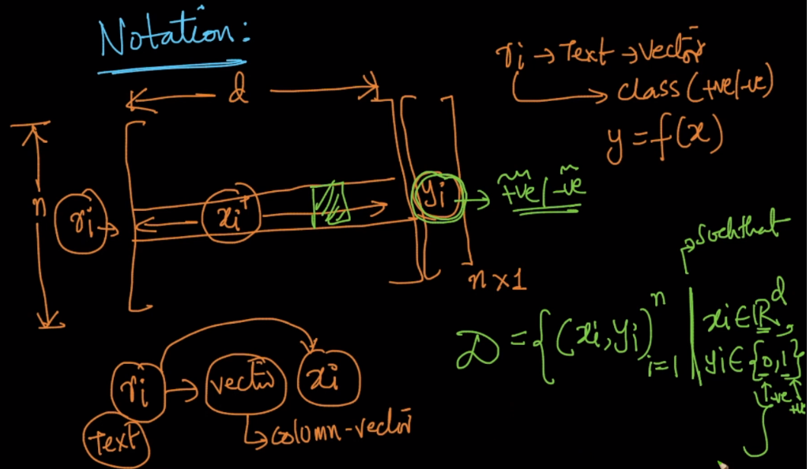

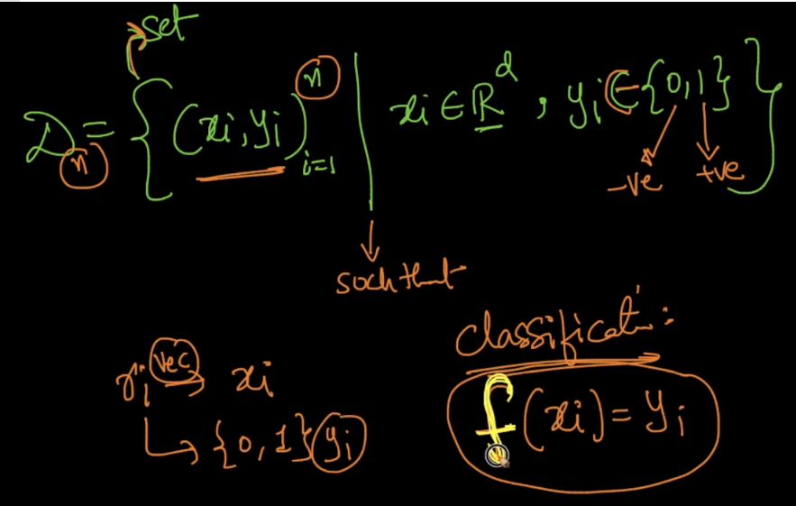

Here n is number of rows or data points

d is no of dimensions or features.

Notes:

Multi label classification: <https://www.analyticsvidhya.com/blog/2017/08/introduction-to-multi-label-classification/>